Chapitre 3. La Cellule
I. L’organisation de la cellule
1. Définition de la cellule
________________________________________________________________________________________________________________________________________________________________________________________________________________________________________________________________________________________________________

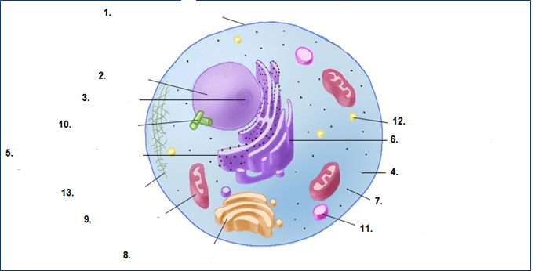
Schéma de la cellule

2. Les organites cellulaires
La cellule est constituée d’une membrane plasmique, d’un noyau et du cytoplasme (qui contient de Cytosol dans lequel baignent tous les organites cellulaires).
- La membrane plasmique
Définition : ______________________________________________________________________________________________________________________________________________________________________________________________________________________________

Rôle : ________________________________________________________________________________________________________________________________________________________________________________________________________________________________________________________________________________________________________

- Le noyau
Définition : ______________________________________________________________________________________________________________________________________________________________________________________________________________________________
Rôle : ______________________________________________________________________________________________________________________________________________________________________________________________________________________________
Structure du noyau :
- __________________ est de forme sphérique et se trouve dans tous les noyaux cellulaires. Certaines cellules en ont 2 ou plusieurs.
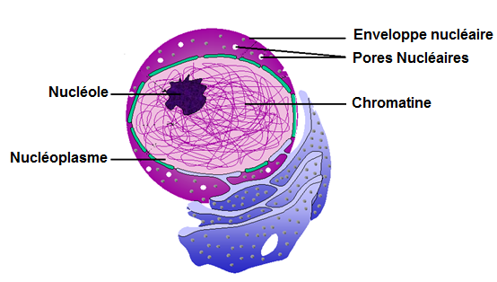
- L’enveloppe nucléaire, comme la membrane plasmique se laisse traverser par diverses substances, mais les grosses molécules ont un passage facilité grâce aux pores nucléaires.
- ____________________ est une solution gélatineuse dans laquelle se trouve nucléole et chromatine.
- _______________________est une molécule d’ADN. Deux chromatines accolées au niveau du centromère forment un chromosome.
4. Le cytoplasme
Définition : ______________________________________________________________________________________________________________________________________________________________________________________________________________________________
5. Réticulum Endoplasmique Granuleux (REG)
Définition : ______________________________________________________________________________________________________________________________________________________________________________________________________________________________
Rôles :________________________________________________________________________________________________________________________________________________________________________________________________________________________
6. Réticulum Endoplasmique Lisse (REL)
Définition : ______________________________________________________________________________________________________________________________________________________________________________________________________________________________
Rôle :
____________________________________________________________________________________________________________________________________________________

7. Les Ribosomes
Définition : ______________________________________________________________________________________________________________________________________________________________________________________________________________________________
Rôles :
____________________________________________________________________________________________________________________________________________________
8. Appareil de Golgi
Définition : ______________________________________________________________________________________________________________________________________________________________________________________________________________________________
Rôle :
______________________________________________________________________________________________________________________________________________________________________________________________________________________________
9. La Mitochondrie
Définition : ______________________________________________________________________________________________________________________________________________________________________________________________________________________________

Rôle :
______________________________________________________________________________________________________________________________________________________________________________________________________________________________
10. Le Centrosome
Définition : ______________________________________________________________________________________________________________________________________________________________________________________________________________________________
Rôles :
______________________________________________________________________________________________________________________________________________________________________________________________________________________________
11. Lysosome
Définition : ______________________________________________________________________________________________________________________________________________________________________________________________________________________________
Rôle :
______________________________________________________________________________________________________________________________________________________________________________________________________________________________
12. Les vacuoles
Définition : ______________________________________________________________________________________________________________________________________________________________________________________________________________________________
Rôle :
______________________________________________________________________________________________________________________________________________________________________________________________________________________________
13. Le cytosquelette
Définition : ______________________________________________________________________________________________________________________________________________________________________________________________________________________________

Rôles :
______________________________________________________________________________________________________________________________________________________________________________________________________________________________

II. La Mitose
1. Définition de la mitose
____________________________________________________________________________________________________________________________________________________________________________________________________________________________________________________________________________________________________________________________________________________________________________________________________________________________________________________________
2. Les différentes étapes de la mitose
Les quatre phases de la mitose sont _______________________________________.

Phase | Schéma | Description
________________ |   

